PRICE LIST FOR NATIONAL AND INTERNATIONAL

INBOUND MARKETING SERVICES



Prices 2023-2024



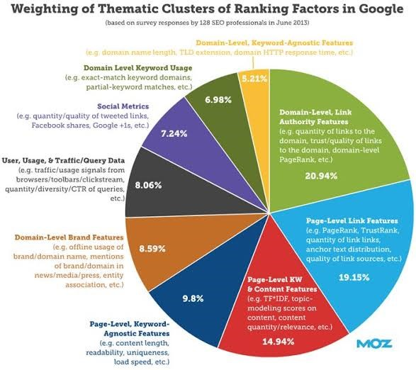

**HUBLINK IS A GOOGLE-ACCREDITED IBM COMPANY DELIVERING SERVICES WORLDWIDE**

Our motto is.

Honesty

* We will never recommend our services to a company that does not need it.

Attention to detail.

* We believe in providing the customer with service excellence to the finest detail.

Revolutionising the generation of enquiries is the name of the game.

* Hublink is aware that the modern buying process starts with Google, and we strive to rank our customers on top.

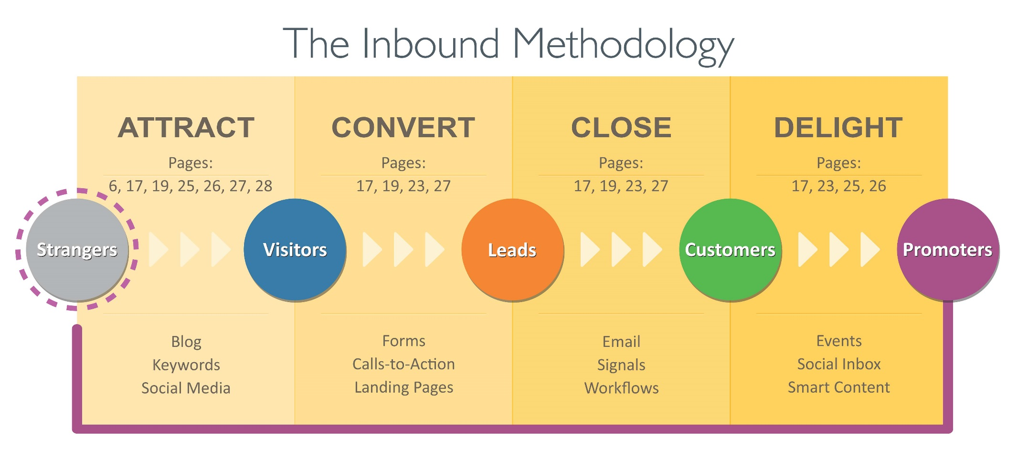

Specialist’s packages

**Basic Packages**

Directory of

H.I.M

(Hublink Inbound Marketing**)**

Page

1. Implementation 4
2. Personification 5
3. Keyword Research 9
4. Traffic Analysis and coal setting 10
5. Audits and Analysis 11
6. Developing a campaign strategy 12
7. Website Action analysis and goals 10
8. Creating the required templates 14
9. Constructing IBM assets 16
10. Development of Documentation 18
11. Template development for conversions 15
12. Strategizing the buyers Journey 20
13. Campaign Analysis and optimisation 21
14. Blogging 22
15. Email Marketing 26
16. Website development 27
17. IBM Consulting and Narrating 28
18. 6 Basic steps of Ux and UI 30

**Allow H.I.M. to**

Welcome you to the world of IBM, now we must set the goals and get to understand the industry and the world of the client.

Hublink will use this opportunity to fully understand the branding requirements of the customer as well as the entities business and marketing goals.

Hublink will also use this occasion to bring to the attention of the client, the importance of the client’s total commitment to the project without which the success of IBM is not possible.

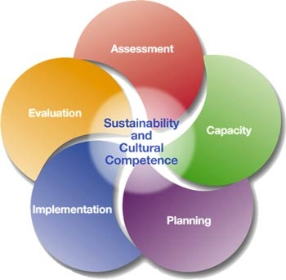

**IMPLEMENTATION**

**Personification**

**& Role-players**

**UNDERSTANDING AND ANALYSING THE TARGET MARKET BY CREATING PERSONAS AND IDENTIFYING THE ROLE PLAYERS IN THE PROJECT**

**Online Skype or Zoom persona workshop**

A Hublink Account Manager will host and facilitate an on line meeting to discuss and categorise different personas to address the following;

* Business pains of the targeted persona
* Business challenges facing the persona.
* Target market penetration
* Future Innovations

|  |  |  |  |  |
| --- | --- | --- | --- | --- |
| Rate |  | 0.055 | 0.043 | 0.063 |
| per Iinterview | R 450.00 | € 24.75 | £19.35 | $28.35 |

**Develop persona profiles.**

We then develop single or multiple persona profiles based on the information received from the interview

|  |  |  |  |  |
| --- | --- | --- | --- | --- |
| Unit |  | 0.055 | 0.043 | 0.063 |
| 1 | R 1,250.00 | € 68.75 | £53.75 | $78.75 |

**Persona attraction**

We value and research messages, topics and keywords that will best communicate with and attract the target persona

|  |  |  |  |  |
| --- | --- | --- | --- | --- |
| Unit |  | 0.055 | 0.043 | 0.063 |
| 1 | R 950.00 | € 52.25 | £40.85 | $59.85 |

Role-players Identification and interviews in person or Skype

|  |  |  |  |  |
| --- | --- | --- | --- | --- |
| Unit |  | 0.055 | 0.043 | 0.063 |
| |  |  |  |  |  | | --- | --- | --- | --- | --- | | per Interview | R 450.00 | € 24.75 | £19.35 | $28.35 |   1 | R 450.00 | € 52.25 | £40.85 | $59.85 |

UNDER



**Strategic Profiling**

We are now ready to identify and capture the data desired for each persona and can thus develop a capturing strategy over a series of interactions with the persona.

|  |  |  |  |  |
| --- | --- | --- | --- | --- |
| Unit |  | 0.055 | 0.043 | 0.063 |
| 1 | R 950.00 | € 52.25 | £40.85 | $59.85 |

**Persona setup.**

The persona profile, messaging and data required to identify the persona are captured within the Hublink persona File

|  |  |  |  |  |
| --- | --- | --- | --- | --- |
| Unit |  | 0.055 | 0.043 | 0.063 |
| 1 | R  1350.00 | € 19.25 | £15.05 | $22.05 |

**Google,**

**The judge of our success.**

The same as with any other profession, you need to have the correct tools and even with the correct tools like always there are many ways to use them. However our experience has indicated that some methods are better than others.

TEST ACCESS TO GOOGLE ANALYTICS AND WEBMASTER

Most business entities already use Google analytics as well as being setup with webmaster. You can provide the Hublink team with access by adding [webmaster@hublink.co.za](mailto:webmaster@hublink.co.za) as a user.

|  |  |  |  |  |
| --- | --- | --- | --- | --- |
| Unit |  | 0.055 | 0.043 | 0.063 |
| 1 | R 350.00 | € 19.25 | £15.05 | $22.05 |

The Google tracking code will weigh and alternate statistics in Google Analytics. This exclusion code, added to a Google analytics profile ensures no discrepancies due to the google tracking.

|  |  |  |  |  |
| --- | --- | --- | --- | --- |
| Unit |  | 0.055 | 0.043 | 0.063 |
| 1 | R 350.00 | € 19.25 | £15.05 | $22.05 |



**Establish and activate the Google Analytics tracking code on the website.**

Should the end user, use their own CRS other than ZOHO, we will code in the page footer with applicable coding their pages to attract and delight visitors.

|  |  |  |  |  |
| --- | --- | --- | --- | --- |
| Rate |  | 0.055 | 0.043 | 0.063 |
| Unit | ZAR | Euro | BP | USD |
| 1 | 100 | 5.5 | 4.3 | 6.3 |

**Competitor website monitoring in Google Analytics.**

After being presented with competitor website information and addresses by the client we will install the Google analytics tool, which will enable more effective use of all applicable tools as well as tracking the overall digital marketing enactment of competitor websites.

|  |  |  |  |  |
| --- | --- | --- | --- | --- |
| Rate |  | 0.055 | 0.043 | 0.063 |
| Unit | ZAR | Euro | BP | USD |
| 1 | 250 | 13.75 | 10.75 | 15.75 |

**Setup Google analytics reporting**

It is important to exclude for example the IP address of the client and their suppliers from the required traffic reports. This is achieved by changing the Google Analytics settings accordingly.

|  |  |  |  |  |
| --- | --- | --- | --- | --- |
| Rate |  | 0.055 | 0.043 | 0.063 |
| Unit | ZAR | Euro | BP | USD |
| 1 | 100 | 5.5 | 4.3 | 6.3 |

**Setup Page settings.**

We will establish and reset the default settings on Pages, which are primarily used for landing pages to reflect the client’s preferences.

|  |  |  |  |  |
| --- | --- | --- | --- | --- |
| Rate |  | 0.055 | 0.043 | 0.063 |
| Unit | ZAR | Euro | BP | USD |
| 1 | 100 | 5.5 | 4.3 | 6.3 |

**Setting up E-Mail in Mailchimp or Bulkmail.**

All Email projects must have an “opt-out” facility, however, there are different unsubscribe options to prevent total unsubscriptions from all email communications.

|  |  |  |  |  |
| --- | --- | --- | --- | --- |
| Rate |  | 0.055 | 0.043 | 0.063 |
| Unit | ZAR | Euro | BP | USD |
| 1 | 100 | 5.5 | 4.3 | 6.3 |

**Setup NAMES for Hublink’s assets**

In cooperation with the client’s staff and domain host, we professionally set up the facility to use Hublink’s landing pages, email and blogging platforms, so as to enhance the expertise portfolio of the company image.

|  |  |  |  |  |
| --- | --- | --- | --- | --- |
| Rate |  | 0.055 | 0.043 | 0.063 |
| Unit | ZAR | Euro | BP | USD |
| 1 | 100 | 5.5 | 4.3 | 6.3 |

Hublink Form integration

Although the appearance remains the same all forms on the website need to be replaced with a Hublink formation form.

|  |  |  |  |  |
| --- | --- | --- | --- | --- |
| Rate |  | 0.055 | 0.043 | 0.063 |
| Unit | ZAR | Euro | BP | USD |
| 1 | 100 | 5.5 | 4.3 | 6.3 |

**Perform the required keyword research**

To target the top, middle or bottom of the sales funnel with different definitive themes can be achieved with assorted digital marketing tools. Every persona developed should be targeted using at least 5 campaigns and more if at all possible.

The Google keyword planner-tool provides a list of plus minus 800 key phrases per campaign which is sorted manually by us relating to thy specific SEO, PPC, blogging or social media campaign implemented.

|  |  |  |  |  |
| --- | --- | --- | --- | --- |
| Rate |  | 0.055 | 0.043 | 0.063 |
| Unit | ZAR | Euro | BP | USD |
| Per 5 Campaigns | 2500 | 137.5 | 107.5 | 157.5 |

**Keywords setup in Google analytics**

The relevant campaign is skilfully insinuated with the keywords discovered during the research conducted of best suited keywords, by using the HubSpot keywords tool.

|  |  |  |  |  |
| --- | --- | --- | --- | --- |
| Rate |  | 0.055 | 0.043 | 0.063 |
| Unit | ZAR | Euro | BP | USD |
| Per 5 Campaigns | 100 | 5.5 | 4.3 | 6.3 |

**KEYWORD RESEARCH**

Search, research and brainstorm keywords, to discover, derive and use the most effective ones.

**TRAFFIC ANALYSIS AND GOAL SETTING**

KEEPING YOUR EYE ON THE BALL

**Situational Analysis: Current Traffic and conversion ratios**

We calculate, by using data from the last twelve months conversion percentages, thru mapping traffic volumes against lead volumes.

|  |  |  |  |  |
| --- | --- | --- | --- | --- |
| Rate |  | 0.055 | 0.043 | 0.063 |
| Unit | ZAR | Euro | BP | USD |
| Per 5 Campaigns | 1450 | 79.75 | 62.35 | 91.35 |

**Set inbound marketing goals.**

Considering past info as well as the client’s wishes, we set realistic traffic, leads and customer goals.

|  |  |  |  |  |
| --- | --- | --- | --- | --- |
| Rate |  | 0.055 | 0.043 | 0.063 |
| Unit | ZAR | Euro | BP | USD |
| Per 5 Campaigns | 350 | 19.25 | 15.05 | 22.05 |



**Competitor Analysis**

We review competitors’ performance on keywords used in their website and digital activity.

|  |  |  |  |  |
| --- | --- | --- | --- | --- |
| Rate |  | 0.055 | 0.043 | 0.063 |
| Unit | ZAR | Euro | BP | USD |
| Per competitor | 350 | 19.25 | 15.05 | 22.05 |

**Content Audit**

We review existing cyber-content and identify what may be used as is or what must be redeveloped.

|  |  |  |  |  |
| --- | --- | --- | --- | --- |
| Rate |  | 0.055 | 0.043 | 0.063 |
| Unit | ZAR | Euro | BP | USD |
| Per client | 1200 | 66 | 51.6 | 75.6 |

**Website Audit**

We review the website, SEO, and inbound friendliness, and make recommendations to improve.

|  |  |  |  |  |
| --- | --- | --- | --- | --- |
| Rate |  | 0.055 | 0.043 | 0.063 |
| Unit | ZAR | Euro | BP | USD |
| Per website | 300 | 16.5 | 12.9 | 18.9 |

**AUDITS AND ANALYSIS**

USING A COMPASS TO GUIDE THE WAY



**Define campaigns and content assets.**

Personas was so developed to focus on the top, middle and bottom of your enquiry funnel, we now develop strategies that will specifically target those areas with assets such as topic relevant blogs and email campaigns.

|  |  |  |  |  |
| --- | --- | --- | --- | --- |
| Rate |  | 0.055 | 0.043 | 0.063 |
| Per campaign | R 500.00 | € 27.50 | £21.50 | $31.50 |

**Setup campaign.**

The developed and approved campaigns are now ready to be placed and linked to google, complete with all the relevant assets (e.g. keywords and landing pages)

|  |  |  |  |  |
| --- | --- | --- | --- | --- |
| Rate |  | 0.055 | 0.043 | 0.063 |
| Per campaign | R 100.00 | € 5.50 | £4.30 | $6.30 |

**DEVELOPING A CAMPAIGN STRATEGY**

Gathering your potencies

In order for us to perform this core function of internet marketing the client needed to have had the following assignments implemented by us;

* Basic IBM Implementation
* Personas
* Keyword research
* Goal setting analysis of
  + Website Traffic
  + Leads
  + Goals
* Competitor audit
* Website and content development or audit
* Campaign strategy

The final game plan and strategic goals will include and utilise;

* SEO
* email
* paid add-words.
* social media
* Your existing database
* Monthly content calendar
* Campaign strategy

|  |  |  |  |  |
| --- | --- | --- | --- | --- |
| Rate |  | 0.055 | 0.043 | 0.063 |
| Per plan | R 8,500.00 | € 467.50 | £365.50 | $535.50 |

THE IBM GAME PLAN

PLANNING TO TURN WISHES INTO GOALS

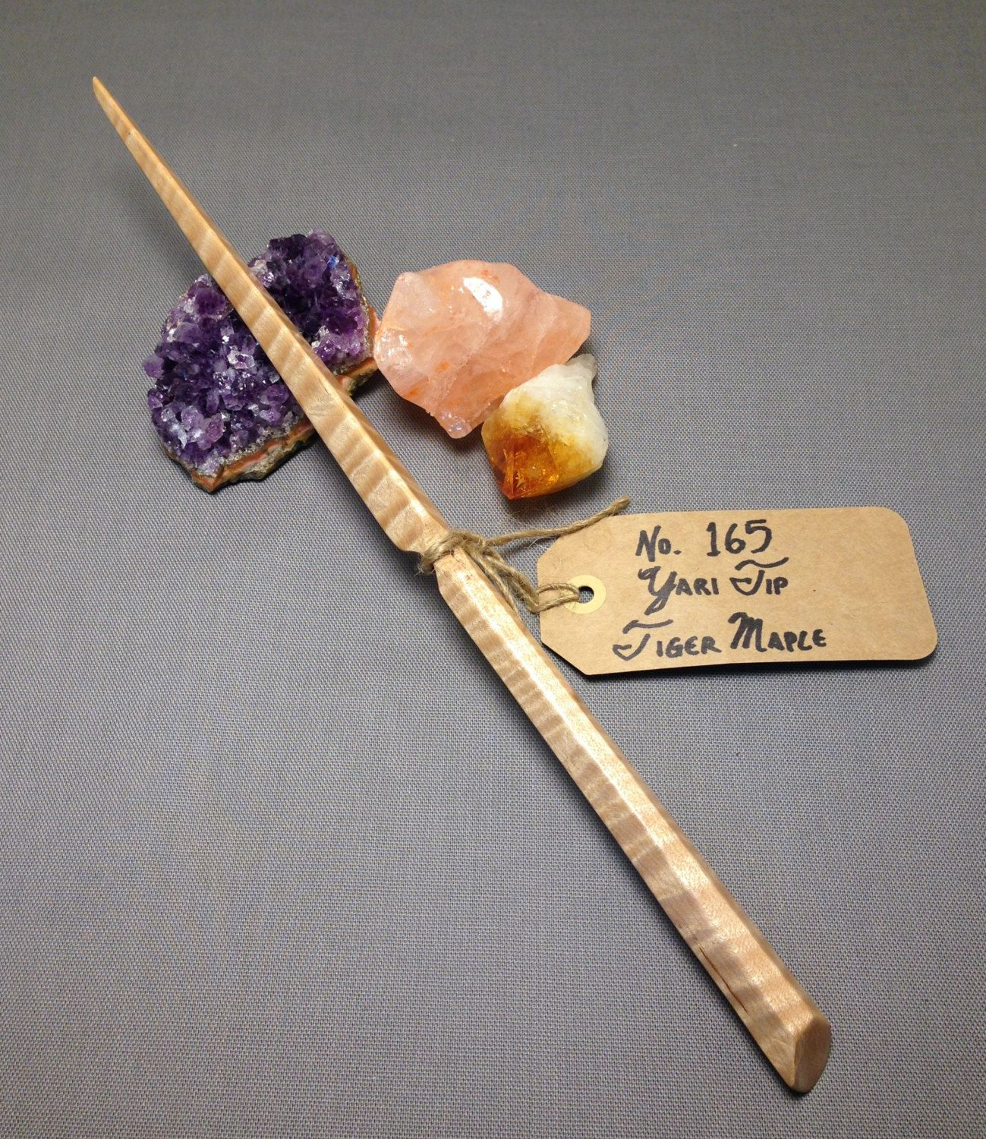

**Thank you and Landing page template design.**

You get to choose your ultimate design, resulting from a brief and presentation of multiple different designs to suit your branding expectations.

|  |  |  |  |  |
| --- | --- | --- | --- | --- |
| Rate |  | 0.055 | 0.043 | 0.063 |
| Per choice | R 2,200.00 | € 121.00 | £94.60 | $138.60 |

**Design of blog Template**

The same as for landing pages you get to choose your one blog template from our designs presented at a brief.

|  |  |  |  |  |
| --- | --- | --- | --- | --- |
| Rate |  | 0.055 | 0.043 | 0.063 |
| Per choice | R 2,200.00 | € 121.00 | £94.60 | $138.60 |

**Design of Email Template**

Again, the ultimate template used will be your choice from multiple designs after consultation and a brief.

|  |  |  |  |  |
| --- | --- | --- | --- | --- |
| Rate |  | 0.055 | 0.043 | 0.063 |
| Per choice | R 2,200.00 | € 121.00 | £94.60 | $138.60 |

CREATING THE REQUIRED TEMPLATES

THIS IS WHERE SKILFUL ART BECOMES SCIENCE

**Re-Design and / or development of website**

Based on a lengthy brief and the supplied brand specification and requirements by you we redesign your existing site or if required by our standards we develop a website using the most modern and current developing tools and templates to your satisfaction.

The HTML designed website does not need Photoshop Designs to

* Hublink sites,
* Hublink Blogging platforms or
* Hublink Email

It is an all-inclusive design and part of the website development.

|  |  |  |  |  |
| --- | --- | --- | --- | --- |
| Rate |  | 0.055 | 0.043 | 0.063 |
| Per Web page | R 6,500.00 | € 121.00 | £94.60 | $138.60 |



RESPONDING TO THE ELECTRONIC DEMAND FOR COMPATIBILITY.

**Short asset (E-Books) creation**

Interview, research and writing of an asset (with 2 reverts)

|  |  |  |  |  |
| --- | --- | --- | --- | --- |
| Rate |  | 0.055 | 0.043 | 0.063 |
| <600 words | R 2,500.00 | € 137.50 | £107.50 | $157.50 |

**Short asset design**

Design an asset into a PDF (excluding image purchase or hire)

|  |  |  |  |  |
| --- | --- | --- | --- | --- |
| Rate |  | 0.055 | 0.043 | 0.063 |
| <600 words | R 1,200.00 | € 66.00 | £51.60 | $75.60 |

**Medium asset creation**

Interview, research and writing of an asset (with 2 reverts)

|  |  |  |  |  |
| --- | --- | --- | --- | --- |
| Rate |  | 0.055 | 0.043 | 0.063 |
| <1500 words | R 3,500.00 | € 192.50 | £150.50 | $220.50 |

**Medium asset design**

Interview, research and writing of an asset (with 2 reverts)

|  |  |  |  |  |
| --- | --- | --- | --- | --- |
| Rate |  | 0.055 | 0.043 | 0.063 |
| <1500 words | R 4,500.00 | € 247.50 | £193.50 | $283.50 |

CONSTRUCTING ASSETS

DESIGNING AND WRITING OF PRIME CONTENT, E-BOOKS, AND CUSTOMER GUIDES TO BE USED IN DIFFERENT CAMPAIGNS

**Primary research on E/book.**

We will develop a questionnaire, build the survey in SurveyMonkey, and develop a respondent recruitment strategy, manage the data collection as well as analysing the data so that a writer produce a quality E-book.

|  |  |  |  |  |
| --- | --- | --- | --- | --- |
| Rate |  | 0.055 | 0.043 | 0.063 |
| Per survey | R 35,000.00 | € 1,925.00 | £1,505.00 | $2,205.00 |



**Long asset creation**

Interview, research and writing of an asset (with 2 reverts)

|  |  |  |  |  |
| --- | --- | --- | --- | --- |
| Rate |  | 0.055 | 0.043 | 0.063 |
| <3500 words | R 14,500.00 | € 797.50 | £623.50 | $913.50 |

**Long asset design**

Interview, research and writing of an asset (with 2 reverts)

|  |  |  |  |  |
| --- | --- | --- | --- | --- |
| Rate |  | 0.055 | 0.043 | 0.063 |
| <3500 words | R 3,750.00 | € 206.25 | £161.25 | $236.25 |

**Writing of 16 blogs to promote Website traffic and assets**.

We write 16 blogs on subject relevant to your landing pages and other assets to promote and create traffic to your website. These blogs will be used for posting on all social media platform, will be 500+ words and will form an integral part of your marketing asset register.

|  |  |  |  |  |
| --- | --- | --- | --- | --- |
| Rate |  | 0.055 | 0.043 | 0.063 |
| Per set of 16 | R 21,500.00 | € 1,182.50 | £924.50 | $1,354.50 |

**Promotional Video**

This South African created video is based on relevant data from all marketing assets and will assist in driving viewers to a landing page, from where they can be converted to leads. (Price based on Quatation)

**Hublink form development.**

We setup a Hublink form

|  |  |  |  |  |
| --- | --- | --- | --- | --- |
| Rate |  | 0.055 | 0.043 | 0.063 |
| Per Form | R 120.00 | € 6.60 | £5.16 | $7.56 |

**Landing Page Content / Video**

Content / video is content primarily used for the purpose of advertising or marketing. We create content optimised to drive conversion on a landing or thank you page. Videos used are created from Shakr or Animoto

|  |  |  |  |  |
| --- | --- | --- | --- | --- |
| Rate |  | 0.055 | 0.043 | 0.063 |
| Per Page  Video | R 350.00  R1200.00 | € 19.25  €73.oo | £15.05  £65.00 | $22.05  $77.00 |

**Landing Page creation**

We create and correctly setup the landing page or thank you page, using exiting templates. (Excluding hire and purchase cost of images)

|  |  |  |  |  |
| --- | --- | --- | --- | --- |
| Rate |  | 0.055 | 0.043 | 0.063 |
| Per Page | R 350.00 | € 19.25 | £15.05 | $22.05 |

**Design of call to action Banners.**

|  |  |  |  |  |
| --- | --- | --- | --- | --- |
| Rate |  | 0.055 | 0.043 | 0.063 |
| Per Image | R 250.00 | € 13.75 | £10.75 | $15.75 |

DEVELOPMENT OF SUPPORTING DOCUMENTATION

**TRANSFORMATION OF THE CONVERSION PROCESS**



**Setup Call to action Banners**

|  |  |  |  |  |
| --- | --- | --- | --- | --- |
| Rate |  | 0.055 | 0.043 | 0.063 |
| Per Banner | R 30.00 | € 1.65 | £1.29 | $1.89 |

**Placement of call-to-action banners on the website**

We insert banners into digital properties (provided the property is hosted on a well-known CRM such as Hubspot WordPress and ZOHO)

|  |  |  |  |  |
| --- | --- | --- | --- | --- |
| Rate |  | 0.055 | 0.043 | 0.063 |
| Per Banner | R 30.00 | € 1.65 | £1.29 | $1.89 |

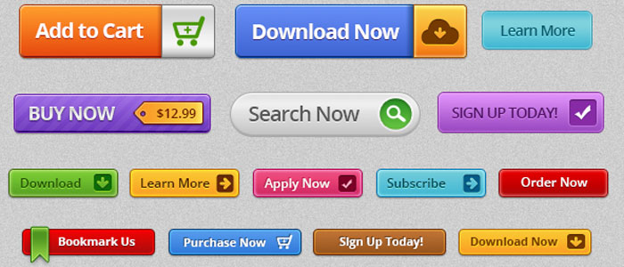

**Strategy Development**.

Considering all the stages of the buyer’s journey, we build a strategy with multiple stages which may be a combination of Email, SMS, social media, web case, podcast or video.

|  |  |  |  |  |
| --- | --- | --- | --- | --- |
| Rate |  | 0.055 | 0.043 | 0.063 |
| Per 10 steps | R 900.00 | € 49.50 | £38.70 | $56.70 |

**Writing of automation Copy**

Taking cognisance of the strategy we produce the content for email and call scripts

|  |  |  |  |  |
| --- | --- | --- | --- | --- |
| Rate |  | 0.055 | 0.043 | 0.063 |
| Per 10 steps | R 2,300.00 | € 126.50 | £98.90 | $144.90 |

**Setup of email.**

Using a standard template, the strategized content is provided or setup.

|  |  |  |  |  |
| --- | --- | --- | --- | --- |
| Rate |  | 0.055 | 0.043 | 0.063 |
| Per 10 steps | R 850.00 | € 46.75 | £36.55 | $53.55 |

**Setup of lists.**

The creation of all requirements for automated reports

|  |  |  |  |  |
| --- | --- | --- | --- | --- |
| Rate |  | 0.055 | 0.043 | 0.063 |
| Per 2 lists | R 200.00 | € 11.00 | £8.60 | $12.60 |

**Setup of workflow.**

We setup the workflow to execute the automation strategy

|  |  |  |  |  |
| --- | --- | --- | --- | --- |
| Rate |  | 0.055 | 0.043 | 0.063 |
| Per 10 steps | R 800.00 | € 44.00 | £34.40 | $50.40 |

STRATEGIZING THE BUYERS JOURNEY

TO “ARRIVE ALIVE” AT THE MARKETING DESTINATION IS OF SIMILAR IMPORTANCE

**Monthly Audit on all live campaigns**

By reviewing and annualising all campaigns we can make recommendations to improve landing pages, paid media, social media and email.

|  |  |  |  |  |
| --- | --- | --- | --- | --- |
| Rate |  | 0.055 | 0.043 | 0.063 |
| Per campaign | R 800.00 | € 44.00 | £34.40 | $50.40 |

**Implementation of campaign audits**

|  |  |  |  |  |
| --- | --- | --- | --- | --- |
| Rate |  | 0.055 | 0.043 | 0.063 |
| Per hour | R 500.00 | € 27.50 | £21.50 | $31.50 |

CAMPAIGN ANALYSIS AND OPTIMISATION

STAGNATION MEANS DEATH.

BLOGGING

**THE CORE OF IBM**

**Author profile**

After an interview with the author *(the person on whose behalf we will ghost write)* we imitate, as far as possible his or her personal style and we align to your brand identity.

|  |  |  |  |  |
| --- | --- | --- | --- | --- |
| Rate |  | 0.055 | 0.043 | 0.063 |
| Per author | R 600.00 | € 33.00 | £25.80 | $37.80 |

**Blog writing**

We write a blog post of between 400 and 600 words after a client interview, online research and a product specialist interview. This includes two reverts, proof reading and management of production of the blog post.

|  |  |  |  |  |
| --- | --- | --- | --- | --- |
| Rate |  | 0.055 | 0.043 | 0.063 |
| Per blog | R 1,250.00 | € 68.75 | £53.75 | $78.75 |

**Refreshing a blog post**

Updating and refreshing an existing blog, two reverts, proof reading and management of production of the blog post.

|  |  |  |  |  |
| --- | --- | --- | --- | --- |
| Rate |  | 0.055 | 0.043 | 0.063 |
| Per blog | R 950.00 | € 52.25 | £40.85 | $59.85 |



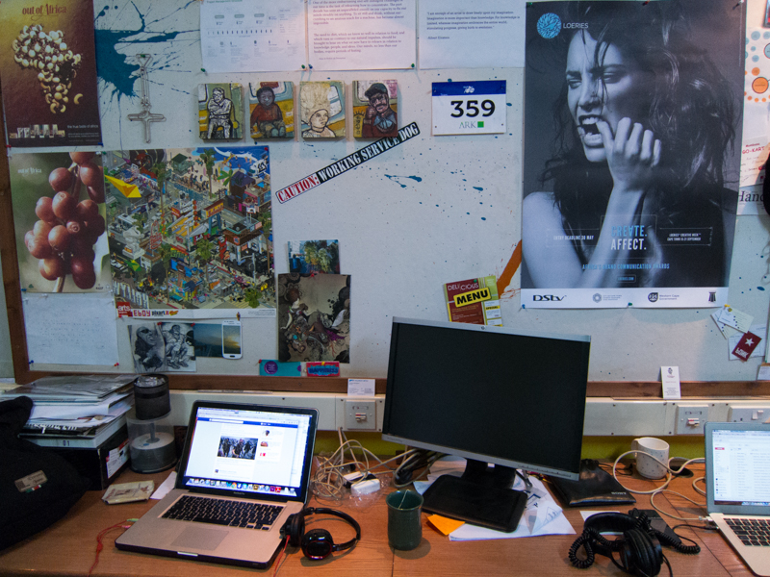

**Upload or update content onto a blogging platform.**

We use a well-known blogging platform such as Google to conduct an on page audit

|  |  |  |  |  |
| --- | --- | --- | --- | --- |
| Rate |  | 0.055 | 0.043 | 0.063 |
| Per blog | R 200.00 | € 11.00 | £8.60 | $12.60 |

**Blogging roster**

We build a 10 post content roster based on the campaign strategy.

|  |  |  |  |  |
| --- | --- | --- | --- | --- |
| Rate |  | 0.055 | 0.043 | 0.063 |
| Per blog | R 2,750.00 | € 151.25 | £118.25 | $173.25 |

Repurposing calendar

We identify two blog postings that should be repurposed and develop a repurposing strategy for these two postings.

|  |  |  |  |  |
| --- | --- | --- | --- | --- |
| Rate |  | 0.055 | 0.043 | 0.063 |
| Per 2 posts | R 550.00 | € 30.25 | £23.65 | $34.65 |

We analyse blog content and the recommendations report that can be used in future blogging rosters.

|  |  |  |  |  |
| --- | --- | --- | --- | --- |
| Rate |  | 0.055 | 0.043 | 0.063 |
| Monthly | R 550.00 | € 30.25 | £23.65 | $34.65 |



**Social media copy**

We write 10 pieces of social media content or 1 video to promote a blog article. These are relevant to each of the selected social media channels.

|  |  |  |  |  |
| --- | --- | --- | --- | --- |
| Rate |  | 0.055 | 0.043 | 0.063 |
| Per 2 posts | R 450.00 | € 24.75 | £19.35 | $28.35 |

**Posting to social media**

Using social platforms to ensure consistency, we post to brand and employee social media. This ensures an even spread of postings.

|  |  |  |  |  |
| --- | --- | --- | --- | --- |
| Rate |  | 0.055 | 0.043 | 0.063 |
| Per 2 posts | R 475.00 | € 26.13 | £20.43 | $29.93 |

**Setup of social media profiles.**

With remote login we guide the user to link their profile within Hublink.

|  |  |  |  |  |
| --- | --- | --- | --- | --- |
| Rate |  | 0.055 | 0.043 | 0.063 |
| Per 2 posts | R 90.00 | € 4.95 | £3.87 | $5.67 |

**Monthly social media audit**

We analyse social media profiles and posts, build a report and make recommendations as well as implementing the recommendations identified.

|  |  |  |  |  |
| --- | --- | --- | --- | --- |
| Rate |  | 0.055 | 0.043 | 0.063 |
| Per 2 posts | R 1,050.00 | € 57.75 | £45.15 | $66.15 |

**Setup of social media profiles.**

We review existing social media profiles, or setup new profiles and provide the required images.

|  |  |  |  |  |
| --- | --- | --- | --- | --- |
| Rate |  | 0.055 | 0.043 | 0.063 |
| per hour | R 750.00 | € 41.25 | £32.25 | $47.25 |

**Monthly social media audit.**

We analyse social profiles and posts, build a report making recommendations to improve social media in the future.

|  |  |  |  |  |
| --- | --- | --- | --- | --- |
| Rate |  | 0.055 | 0.043 | 0.063 |
| per hour | R 600.00 | € 33.00 | £25.80 | $37.80 |

**Implementation of audit recommendations**

We spend one hour implementing the recommendations identified in the report.

|  |  |  |  |  |
| --- | --- | --- | --- | --- |
| Rate |  | 0.055 | 0.043 | 0.063 |
| per hour | R 450.00 | € 24.75 | £19.35 | $28.35 |

**Setup Social Inbox.**

We setup 5 streams to monitor twitter based on keywords, lists and profiles.

|  |  |  |  |  |
| --- | --- | --- | --- | --- |
| Rate |  | 0.055 | 0.043 | 0.063 |
| 5 streams | R 700.00 | € 38.50 | £30.10 | $44.10 |

**Managing social Inbox**

We spend 1 hour per works day to monitor Social Inbox, respond to relevant Tweets and follow relevant users via social Inbox.

|  |  |  |  |  |
| --- | --- | --- | --- | --- |
| Rate |  | 0.055 | 0.043 | 0.063 |
| Per 1 hour working days | R 5,000.00 | € 275.00 | £215.00 | $315.00 |

**Setup of social media profile**

We review existing social media profiles, or set-up new profiles and provide the relevant copy and required images.

|  |  |  |  |  |
| --- | --- | --- | --- | --- |
| Rate |  | 0.055 | 0.043 | 0.063 |
| per hour | R 700.00 | € 38.50 | £30.10 | $44.10 |

EMAIL

MARKETING

PROMOTING YOUR ASSETS

**Write email copy**

We write a promotional emails to be used in a project or to accompany a news letter

|  |  |  |  |  |
| --- | --- | --- | --- | --- |
| Rate |  | 0.055 | 0.043 | 0.063 |
| <100 words | R 1,050.00 | € 57.75 | £45.15 | $66.15 |

**Build email in Mailchimp or Bulkmail**

Using existing email templates or we create an email using an existing or created email.

|  |  |  |  |  |
| --- | --- | --- | --- | --- |
| Rate |  | 0.055 | 0.043 | 0.063 |
| <100 words | R 750.00 | € 41.25 | £32.25 | $47.25 |

**Import email list.** We upload a CSV file (already in the correct format) into mailchimp or Bulkmail contacts

|  |  |  |  |  |
| --- | --- | --- | --- | --- |
| Rate |  | 0.055 | 0.043 | 0.063 |
| per list | R 150.00 | € 8.25 | £6.45 | $9.45 |

**Email Marketing Audit**

We analyse the email project, create a report and make recommendations for future projects

|  |  |  |  |  |
| --- | --- | --- | --- | --- |
| Rate |  | 0.055 | 0.043 | 0.063 |
| per project | R 500.00 | € 27.50 | £21.50 | $31.50 |



A **BRAND ASSET** IS A TOOL THAT ENHANCES YOUR PRODUCTS IMAGE, SLOGANS, ADVERTISING, PUBLICITY, SALES, PROMOTIONS AND CUSTOMER SERVICE. IT HELPS TO CREATE A MEANINGFUL IDENTITY THAT BUILDS EMOTIONAL. BONDS WITH YOUR TARGET AUDIENCE.

Your website must be your single biggest cyberspace brand asset you will and must invest in

|  |  |  |  |  |
| --- | --- | --- | --- | --- |
| Rate |  | 0.055 | 0.043 | 0.063 |
| per page | R 1,500.00 | € 82.50 | £64.50 | $94.50 |

**Website maintenance retainer**

The internet is constantly changing and even after your website has been designed with the most up to date technology, so to wait for the next periodic website re-design is no longer viable. Now constant micro changes to a website retains its current status.

|  |  |  |  |  |
| --- | --- | --- | --- | --- |
| Rate |  | 0.055 | 0.043 | 0.063 |
| per hour | R 450.00 | € 24.75 | £19.35 | $28.35 |

Webpage copy writing

|  |  |  |  |  |
| --- | --- | --- | --- | --- |
| Rate |  | 0.055 | 0.043 | 0.063 |
| < 400 words | R 600.00 | € 33.00 | £25.80 | $37.80 |

RESPONSIVE AND AGILE WEBSITE DEVELOPMENT AND MAINTENANCE

CULTIVATING AND ASSERTING YOUR BIGGEST BRAND ASSET



**General Consulting**

|  |  |  |  |  |
| --- | --- | --- | --- | --- |
| Rate |  | 0.055 | 0.043 | 0.063 |
| per hour | R 600.00 | € 33.00 | £25.80 | $37.80 |

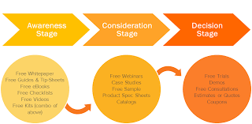

INBOUND MARKETING CONSULTING AND REPORTING

***SA Summary Price list for IBM Services***

Website development up to 7 pages R 14,100.00

Landing Page 5 sections R 4,900.00

Persona creation each R 3,950.00

Competitors (4) Analysis R 2,500.00

Keyword Research R 1,500.00

Website traffic analysis R 750.00

Blog writing 450 -600 words R 830.00

E-Book 10 pages (Customer input) R 5,500.00

Animation video R 1,500.00

Email Campaign (Customer Database) R 3,500.00

Social media setup R 1,200.00

Social Media monitoring (annual) R 2,500.00

Consulting and reporting (per month 3 hours) R 1,850.00

___________________________

Kyknet Afr Corporate Video (10% discount 30 sec video) R 14,600.00

Kyknet Bilingual Corp Video (10% Discount 30 Sec video) R 19,000.00

Kyknet Afrikaans Corp Video (10% Discount 1 min video) R 28,000.00

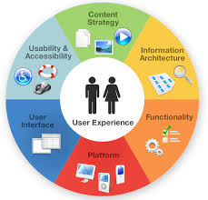

6 Basic steps to ensure a great UX and UI Experience